**CenEats**

   
 

Submitted by:   :)

Submitted to:   Ilir Dema

ICET Department,

School of Engineering Technology and Applied Science

Progress Campus, Block A

Centennial College

Discipline:   Software Engineering 

Due Date:    February 05, 2019

# Declaration of Sole Authorship

We, :) , confirm that this work submitted for assessment is our own and is expressed in our own words. Any uses made within it of the works of any other author, in any form (ideas, equations, figures, texts, tables, programs), are properly acknowledged at the point of use. A list of the references used is included.

Signed:   Devin Young, 300894616 (Software Engineering Technology)

Date: February 05, 2019

# Abstract

CenEats is an online website that allows students and faculty members to efficiently order food in advance from any restaurant at Centennial College Progress campus. Have you ever experienced waiting an unbearable amount of time in line to order food, and for your food to be ready? Well many can probably relate to this problem, but with CenEats, simple problems like this can be solved. From ordering at your favourite restaurant at Centennial to writing a review about your least favourite experience at a restaurant, everything you can ask for is offered by CenEats. This website’s main priority is to reduce waiting time in lines at restaurants to encourage more students and faculty to use the restaurant facilities at Centennial.

**Table of Contents**

**Declaration of Sole Authorship** **2**

**Abstract** **3**

**List of Figures** **6**

**List of Tables** **7**

**1.0 INTRODUCTION** **8**

**2.0 METHODOLOGY AND RESULTS** **9**

2.1 Literature Review 9

2.2 Proposed Solution 9

2.3 User Role Modelling 10

2.3.1 Brainstorm and Group 10

2.3.2 Consolidated User Roles 11

2.3.3 Description of User Roles and Persona 12

2.3.4 Additional Documentation 13

2.4 Release 1.0 14

2.4.1  User Stories 14

2.4.2  Additional Documentation 18

2.4.3  Release Plan 1.0 19

2.4.4  Iteration Plan (Release 1.0) 20

2.4.5 Additional Documentation 21

2.4.6  Progress Monitoring 22

2.4.7  Acceptance Tests for Release 1.0 23

2.5 Release 2.0 25

2.5.1  User Stories 25

2.5.2  Additional Documentation 26

2.5.3   Release Plan 2.0 27

2.5.4   Iteration Plan (Release 2.0) 28

2.5.5   Additional Documentation 29

2.5.6   Progress Monitoring 30

2.5.7   Acceptance Tests for Release 2.0 31

**3.0 CONCLUSIONS** **32**

**4.0 RECOMMENDATIONS** **33**

**CREDITS, LICENSE, AND REFERENCES** **34**

Credits 34

License 34

References 34

**APPENDIX A (DESIGN DOCUMENT)** **35**

**APPENDIX B (TEST PLAN)** **36**

1.0 Introduction 36

1.0.1   Goals 36

1.0.2   Assumptions 36

1.0.3   Risks And Assets 36

Describe the elements that might positively influence testing on the project. 36

2.0 Scope 36

2.0.1   Features To Be Tested 36

2.0.2    Features Not To Be Tested 36

3.0 Testing Procedures 37

3.0.1   Test Objectives 37

3.0.2   Types Of Testing 37

3.0.2.1   Unit Testing 37

3.0.2.2   Integration Testing 37

3.0.2.3   Acceptance Testing 37

3.0.2.4   Stress Testing 38

3.0.2.5   Performance Testing 38

3.0.3   Testing Tools 38

4.0 Schedule and Deliverables 38

**APPENDIX C (END-USER & ADMINISTRATOR MANUALS)** **40**

# List of Figures

Figure 1: Organizing the user role cards on a table [1]. 10

Figure 2: The consolidated role cards [1]. 11

Figure 3: Example of a “consolidated” low-fidelity prototype. Note that each “individual” low-fidelity prototype is developed for each user role [1]. 15

Figure 4: A story with notes providing additional detail [1]. 15

Figure 5: The revised front of a story card with only the story and questions to be discussed [1]. 16

Figure 6: Details that imply test cases are separated from the story itself. Here they are shown on the back of the story card [1]. 16

Figure 7: An example of a constraint story card [1]. 16

# List of Tables

Table 1: The Must-Have stories for Release x.y [1]. 17

Table 2: The Should-Have stories for Release x.y [1]. 17

Table 3: Disaggregated tasks per story [1]. 20

Table 4: Progress and changes for all Iterations for Release 1.0 [1]. 22

Table 5: Stories, acceptance tests, and contributors for Release 1.0 (Green=Accepted; Red=Rejected; Black=Not started). 24

# 1.0 INTRODUCTION

CenEats will be an online restaurant ordering website strictly for Centennial College students and faculties, to reduce the chaotic traffic and long waiting time in lines for orders. The main problem today is students and faculties don’t have the time and patience to wait in these long lines due to their busy class schedules, where sometimes there is only ten minutes to get to their restaurant destination and order food. With CenEats, all representatives from Centennial College can order online from any restaurant in the Progress campus and pick up there order when it is ready. This will allow students and faculties to get their food and make it to their classes on time.

**Objectives**

* Reduce or eliminate the time of waiting in line for your order
* To provide students and the faculties the opportunity to dine efficiently, thus improving educational results
* Increase the amount of customers at each restaurant
* Provide easy to use functionality to successfully order online from a restaurant
* Grant the college a better reputation by improving accessibility

# 2.0 METHODOLOGY AND RESULTS

## 2.1 Literature Review

Similar to Uber Eats and Skip the Dishes, but without the delivery part.

## 2.2 Proposed Solution

The solution to this business need is to build an easy to use and efficient restaurant ordering platform as a go to option for students and faculties to order food from restaurants at Centennial College.

It’s been discussed that a proper eating schedule improves a person’s performance. Not only would CenEats provide the accessibility to benefit students and professors educationally, but for all members of Centennial it’ll help with everyday activities.

Benefits of doing this project are decreasing/eliminating the waiting time in lines for waiting for your restaurant order, while also increase the number of customers at any selected restaurants.

The creation of the website will boost the school’s reputation, which in turn brings in more enrollments of students and professors wanting to use CenEats. This is a beneficial factor for Centennial College.

## 2.3 User Role Modelling

### 2.3.1 Brainstorm and Group

Show the results of your brainstorming session for identifying initial user roles and how they are organized (see Figure 1). Discuss each user role identified and the arrangement of Figure 1.

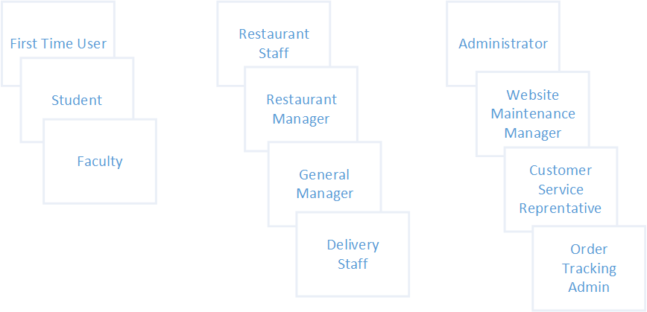

Figure 1: Organizing the user role cards on a table [1].

### 2.3.2 Consolidated User Roles

Show the consolidated user roles (see Figure 2). Discuss the results of Figure 2, focusing on why some roles were merged, removed, and/or added.

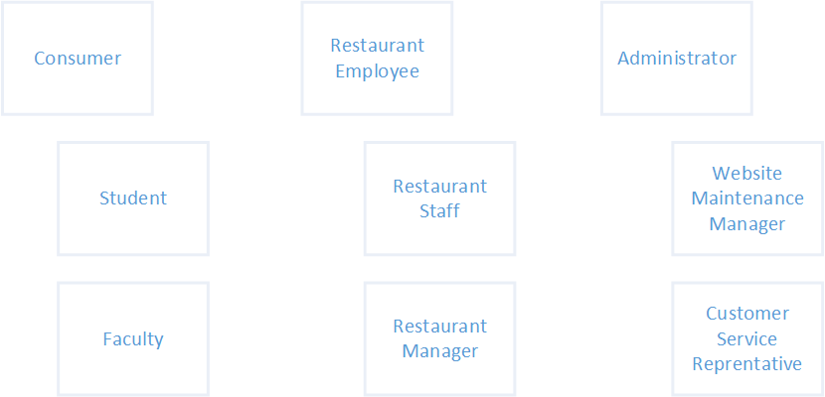

Figure 2: The consolidated role cards [1].

## Discussions

According to our discussion, we removed first time user from the consumer group and delivery staff from restaurant employee group. Keep in mind that consumer, restaurant employee, and administrator are just groups titles that we categorized user roles under.

Reason to remove first time user is because visitors are not familiar with the food suppliers in Centennial. They might have no idea where to pick up the food. In addition, registering will take even longer time compared to order food at the counter. Last but not least, visitors often do not have the situation where they only have 10 minutes break between two classes to buy food. We keep student and faculty as two types of users based on the faculty will be allowed to use promo codes to get discounts on their orders.

Reason to remove deliver staff is because we found there are both technical and business issues. From technical point of view, it is hard to locate the consumer precisely in the building. Even though we can use classrooms to identify the location, students will move from one place to another during the break. From business point of view, hiring deliver staff is also extra cost. Delivering food to the classroom directly also interrupts the lecture. We keep restaurant staff because they need to update the order status after student or faculty pick up the food. The restaurant manager will take care of the total available food amount and update based on the inventory. General Manager oversees the information across all the restaurants.

In terms of admin, we think its responsibility shall be separate into three parts. Website maintenance manager takes care of the website functionalities. Customer service manager is in charge of customer complaints and other services. Order tracking admin will track KPIs for each order such as the average wait time.

### 2.3.3 Description of User Roles and Persona

## Details

Details of each role:

Student:

Will use this app very often. They are considered as major users of this app. They are very familiar with computers and apps, and open to new technologies, Students have high level of expertise within their domain. Their goal is after convenience with good experience as well. Students will use this application to order from a restaurant of their choice from Centennial college.

Faculty:

Will use this app often. They are the second largest group of users. They are well educated and have very high levels in their domain. Their goal is after convenience mainly. Faculty have the same roles as the students and will use this application for ordering purposes.

Restaurant staff:

Will use this app very often. Most of them are as same age as students. Willing to embrace the new technology. Require low level of expertise in their domain with CenEats. Their goal is after convenience like how to process the order efficiently. Restaurant staff will use this application to view customer orders from the CenEats and confirm that the order is ready.

Restaurant Manager:

Sometimes use this app to check or update inventory status if a certain item runs out of stock. They may use this app at a relative low level of proficiency. Restaurant Manager has low level of expertise within their domain, while the General Manager contain a medium level of expertise. Their goal is after convenience. Restaurant Manager will report all their inventory stock problems to the General Manager in charge of all restaurants using CenEats, the General Manager is responsible for updating the inventory status on CenEats

Website Maintenance Manager:

Will use this app very often. They will monitor the daily status of the website. They have a very high level of proficiency and expertise in their domain. Website Maintenance Manager desire a rich experience using this application as their role is to keep the system up and running at all time.

Customer Service Rep:

Will use this app with high frequency to deal with customer complaints and order tracking problems. They have a medium high level of proficiency and expertise in their domain to use this app. Their goal is after convenience but also desire a rich experience in order to monitor the CenEats daily of any issues or complaints. Customer Service Representative is responsible for dealing with customer complaints and issues that are reported in the review section of CenEats, while Order Tracking Admin is responsible for keeping track of all order issues that may occur on the application.

### 2.3.4 Additional Documentation

Video of User Roles: <https://drive.google.com/open?id=1CM4vmuWhg_xaGE3UmulzSWxkwPSd_6w6>

## 2.4 Release 1.0

### 2.4.1  User Stories

**Low Fidelity Prototype**



**Description**

**Login Page** - The authentication Page where all users will be directed to get full access to the web app. You can either login as a student/faculty, admin, or restaurant.

**Home Page** - This page is the main page for navigation to other pages and also displays the restaurants available for order selection.

**Order Page** - This page is where all the ordering functionalities take place for students and faculties and will be done in a series of order pages.

**Review Page** - This page is where all the review functionalities takes place and also will be done in a series of review pages.

**Restaurant View** - Restaurant members are directed to this page after successful authentication on the login page. Restaurant staff can view orders and restaurant managers will be able to update the order item stock using this page.

**Admin View** - This is where the main monitoring of the page happens with graphs to display user interactions with CenEats.

**User Stories**

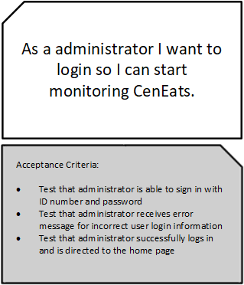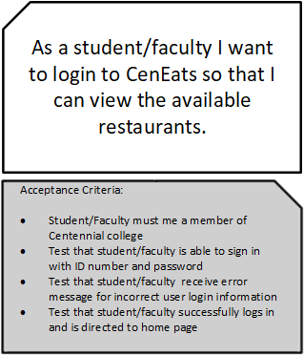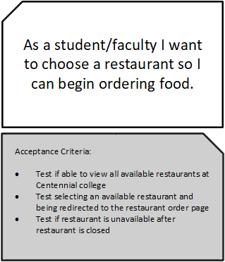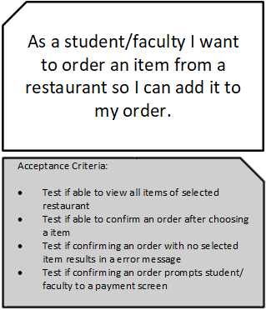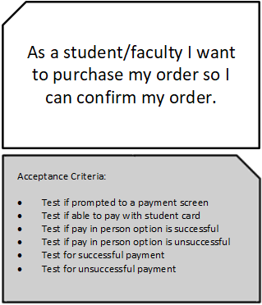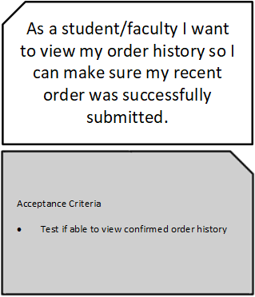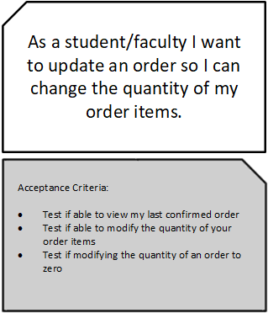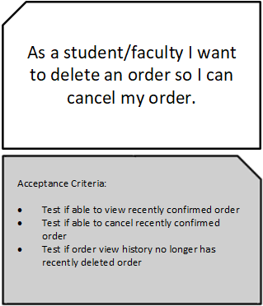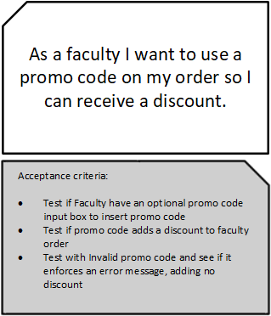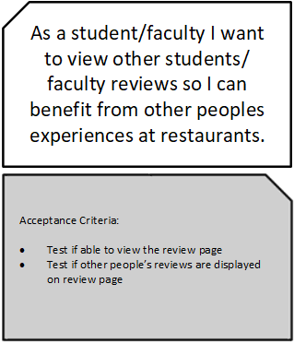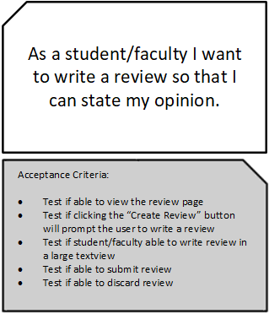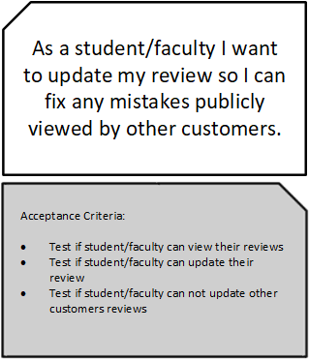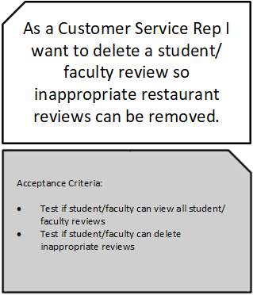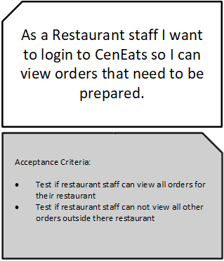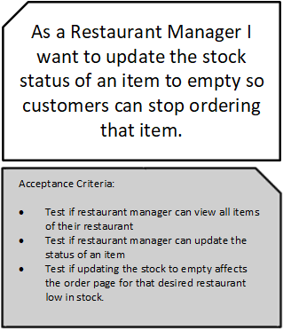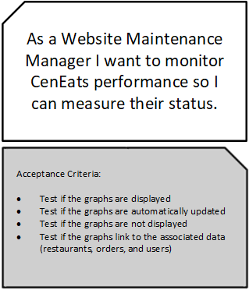

**Estimating User Stories**

Here we have estimated our user stories from a weight of 1 to 5, where 1 is considered easy and 5 is most difficult.

|  |  |
| --- | --- |
| Story | Estimate |
| As a student/faculty I want to login to CenEats so that I can view the available restaurants. | 2 |
| As a administrator I want to login so I can start monitoring CenEats. | 2 |
| As a student/faculty I want to choose a restaurant so I can begin ordering food. | 1 |
| As a student/faculty I want to order an item from a restaurant so I can add it to my order | 4 |
| As a student/faculty I want to purchase my order so I can confirm my order. | 2 |
| As a student/faculty I want to view my order history so I can make sure my recent order was successfully submitted. | 2 |
| As a student/faculty I want to delete an order so I can cancel my order. | 2 |
| As a student/faculty I want to view other students/faculty reviews so I can benefit from other peoples experiences at restaurants. | 2 |
| As a student/faculty I want to write a review so that I can state my opinion. | 3 |
| As a Customer Service Rep I want to delete a student/faculty review so inappropriate restaurant reviews can be removed. | 2 |
| As a Restaurant staff I want to login to CenEats so I can view orders that need to be prepared. | 4 |
| As a Restaurant Manager I want to update the stock status of an item to empty so customers can stop ordering that item. | 5 |
| As a student/faculty I want to update an order so I can change the quantity of my order items. | 3 |
| As a faculty I want to use a promo code on my order so I can receive a discount. | 3 |
| As a student/faculty I want to update my review so I can fix any mistakes publicly viewed by other customers. | 3 |
| As a Website Maintenance Manager I want to monitor CenEats performance so I can measure their status. | 5 |

### 2.4.2  Additional Documentation

Low-Fidelity-Prototype and User Stories Video:

### 2.4.3  Release Plan 1.0

**Must Have Stories**

|  |  |
| --- | --- |
| Story | Estimate |
| As a student/faculty I want to login to CenEats so that I can view the available restaurants. | 2 |
| As a administrator I want to login so I can start monitoring CenEats. | 2 |
| As a student/faculty I want to choose a restaurant so I can begin ordering food. | 1 |
| As a student/faculty I want to order an item from a restaurant so I can add it to my order | 4 |
| As a student/faculty I want to purchase my order so I can confirm my order. | 2 |
| As a student/faculty I want to view my order history so I can make sure my recent order was successfully submitted. | 2 |
| As a student/faculty I want to delete an order so I can cancel my order. | 2 |
| As a student/faculty I want to view other students/faculty reviews so I can benefit from other peoples experiences at restaurants. | 2 |
| As a student/faculty I want to write a review so that I can state my opinion. | 3 |
| As a Customer Service Rep I want to delete a student/faculty review so inappropriate restaurant reviews can be removed. | 2 |
| As a Restaurant staff I want to login to CenEats so I can view orders that need to be prepared. | 4 |
| As a Restaurant Manager I want to update the stock status of an item to empty so customers can stop ordering that item. | 5 |

**Should-Have Stories**

|  |  |
| --- | --- |
| Story | Estimate |
| As a student/faculty I want to update an order so I can change the quantity of my order items. | 3 |
| As a faculty I want to use a promo code on my order so I can receive a discount. | 3 |
| As a student/faculty I want to update my review so I can fix any mistakes publicly viewed by other customers. | 3 |
| As a Website Maintenance Manager I want to monitor CenEats performance so I can measure their status. | 5 |

**Release Plan**

|  |  |
| --- | --- |
| Iteration 1(March 20, 2019) | Iteration 2 (April 10, 2019) |
| As a student/faculty I want to login to CenEats so that I can view the available restaurants. | As a student/faculty I want to update an order so I can change the quantity of my order items. |
| As a administrator I want to login so I can start monitoring CenEats. | As a faculty I want to use a promo code on my order so I can receive a discount. |
| As a student/faculty I want to choose a restaurant so I can begin ordering food. | As a Customer Service Rep I want to delete a student/faculty review so inappropriate restaurant reviews can be removed. |
| As a student/faculty I want to order an item from a restaurant so I can add it to my order | As a Restaurant staff I want to login to CenEats so I can view orders that need to be prepared. |
| As a student/faculty I want to purchase my order so I can confirm my order. | As a Restaurant Manager I want to update the stock status of an item to empty so customers can stop ordering that item. |
| As a student/faculty I want to view my order history so I can make sure my recent order was successfully submitted. | As a student/faculty I want to write a review so that I can state my opinion. |
| As a student/faculty I want to delete an order so I can cancel my order. | As a student/faculty I want to update my review so I can fix any mistakes publicly viewed by other customers. |
| As a student/faculty I want to view other students/faculty reviews so I can benefit from other peoples experiences at restaurants. | As a Website Maintenance Manager I want to monitor CenEats performance so I can measure their status. |
|  |  |
|  |  |

### 2.4.4  Iteration Plan (Release 1.0)

The following are required for this section:

1. Present each iteration plan with tables showing disaggregated tasks per story; a sample is shown in Table 3. See also the *Planning an Iteration* deliverable.
2. Discuss any discrepancies between the estimated and actual ideal time required to complete the tasks for the Table mentioned above.

|  |  |  |  |
| --- | --- | --- | --- |
| Task | Who | Estimate | Actual |
| Code login screen | James Qui | 2 | 3 |
| Code restaurant page | Kris Campbell | 1 | 3 |
| Code Order Page | Devin Young | 3 | 5 |
|  |  |  |  |
|  |  |  |  |
|  |  |  |  |
|  |  |  |  |

|  |
| --- |
| Table 3: Disaggregated tasks per story [1].  https://lh4.googleusercontent.com/XeQi1HulutY2JRQ6keiIBwQAABwmYtP7t1GjQFo1b4WaGRlCZDzp_VFe0oAvqmD85w5JDufu7dIFrP2Z7WLEBL2hjhkyLrpqtic6cLaESTPtdGqlVWXe6H9yRPLc_mYB_TqyvmU |

### 2.4.5 Additional Documentation

For this section, include 1 of 4 videos from your Iteration Planning meetings (recall that you have a total of 4 Iteration Planning meetings)[1]:

1. Showing how your team disaggregated stories into their constituent tasks.
2. How developers on your team volunteer and take responsibilities for tasks.

Provide the file name and URL to the video(s) in your shared folder or YouTube channel.

### 2.4.6  Progress Monitoring

The following are required for this section:  
A table summarizing progress and changes during a release with supporting discussion; a sample is shown in Table 4. Notice in Table 4 that all iterations are shown per Release[2]. Also, see *Table 1* in the *Measuring and Monitoring Progress* deliverable.

|  |
| --- |
| Table 4: Progress and changes for all Iterations for Release 1.0 [1].  https://lh5.googleusercontent.com/4Ap6uEsBxYifEjZuDn1Lj7V4URVZyBH7pdlR3GI1Muc-OxP7iE51R_qXc06cBoPtAJLqXna8S1RwR7DO1t-PTcJj0Jv5ybINsjn94Z9SUdpIpFBFQnJxG7flKVvm15qJHJB4H9Y |

### 2.4.7  Acceptance Tests for Release 1.0

The following are required for this section:

1. A table of stories and their associated acceptance tests for this Release as shown below in the sample in Table 5.
2. The link to your video demo for Release 1.0 stored either in a cloud drive, or your YouTube channel.

Table 5: Stories, acceptance tests, and contributors for Release 1.0 (Green=Passed; Red=Failed).

|  |  |  |
| --- | --- | --- |
| **Full description of user story** | **Acceptance test(s)** | **Name(s) of contributing Developer(s)** |
| As an User, I can … so that ….[3] | Test with inputs ….  Expected outcome: ...  Test with inputs ….  Expected outcome: ... | Susan Smith,  Jay Johnson |
| As an Administrator, I can … so that ….[4] | Test with inputs ….  Expected outcome: ...  Test with inputs ….  Expected outcome: ...  Test with inputs ….  Expected outcome: ...  Test with inputs ….  Expected outcome: ... | Susan Smith,  Jay Johnson,  Shannon Shore,  George Gavinson |
| As an User, I can … so that …. | Test with inputs ….  Expected outcome: ...  Test with inputs ….  Expected outcome: ...  Test with inputs ….  Expected outcome: ... | Jay Johnson,  Shannon Shore,  George Gavinson |
| As an User, I can … so that ….[5] | Test with inputs ….  Expected outcome: ... | Shannon Shore |
| As a Guest, I can … so that …. | Test with inputs ….  Expected outcome: ...  Test with inputs ….  Expected outcome: ...  Test with inputs ….  Expected outcome: ...  Test with inputs ….  Expected outcome: ... | Susan Smith,  Jay Johnson,  Shannon Shore,  George Gavinson,  Abbey Appleby,  Brian Bolt |

2.5 Release 2.0

Release 2.0 has essentially the same structure as Release 1.0.

### 2.5.1  User Stories

If your team wrote enough stories to cover up to or beyond Release 2.0 during your first story-writing workshop as described in the *User Stories* section 2.4.1, then your team will not need to hold a second formal workshop.

If a second workshop was held, submission for this section is the same as section 2.4.1.

### 2.5.2  Additional Documentation

Include this section in your Technical Report only if your team required a second formal story-writing workshop. If a second workshop was held, submission for this section is the same as section 2.4.2.

### 2.5.3   Release Plan 2.0

The requirements for this section are the same as section 2.4.3.

### 2.5.4   Iteration Plan (Release 2.0)

The requirements for this section are the same as section 2.4.4.

### 2.5.5   Additional Documentation

This section is required ONLY IF your team submitted materials for section 2.4.5.

### 2.5.6   Progress Monitoring

The requirements for this section follow the same requirements as in section 2.4.6 except progress monitoring is for Iterations for Release 2.0.

### 2.5.7   Acceptance Tests for Release 2.0

The requirements for this section follow the same requirements as in section 2.4.7 except acceptance testing is for stories allocated for Release 2.0 and incomplete stories subsequently moved from Release 1.0.

# 3.0 CONCLUSIONS

A conclusion interprets the data found in the Body. It is reasoned judgment and not opinions. Consider the variables. Relate cause and effect. Analyze, evaluate, make comparisons and contrasts. Base the conclusion on fact.

# 4.0 RECOMMENDATIONS

Recommendations are not required for all studies. They suggest a course of action and would generally be provided when there are additional areas for study, or if the reason for the TR was to determine the best action going forward.

# CREDITS, LICENSE, AND REFERENCES

## Credits

Provide any credits here. The following are examples:

Author of the template graphic layout : Hao Lac <haolac.at.centennial@gmail.com>

Author of the template explanation text : John Doe <[john.doe@centennialcollege.ca](mailto:john.doe@centennialcollege.ca)>

## License

State the license granted with your system. For example:

Permission is granted to copy, distribute and/or modify this document under the terms of the GNU Free Documentation License, Version 1.1 or any later version published by the Free Software Foundation; with no Invariant Sections, with no Front-Cover Texts, and with no Back-Cover Texts. A copy of the license is included in the appendix entitled "GNU Free Documentation License".

## References

[1] Cohn, Mike. 2004. *User Stories Applied: For Agile Software Development*, Addison-Wesley Professional.

# APPENDIX A (DESIGN DOCUMENT)

Traditional approaches to software development, in contrast to that of Agile approaches, place a great deal of emphasis on upfront design. The Agile approach to design is quick sessions that seek the simplest solution and then incrementally build on that solution. A quick design session can include the use of CRC cards that can ultimately lead to the generation of UML diagrams.

Using Agile approaches to software development does not mean you are limited to using only Agile techniques. If you feel that a technique (e.g., use case or interaction design scenario) is more suitable, or better conveys the features of your system to your users, then use it.

In this section, you are required to submit and discuss the following:

* A paper prototype of your application/system.
* Any design work your team has done in developing your system including CRC cards, UML diagrams, ERD diagrams, use cases, interaction design scenario, etc.

# APPENDIX B (TEST PLAN)

## 1.0 Introduction

### 1.0.1   Goals

Summarize the testing goals for project.

### 1.0.2   Assumptions

Any assumptions which may affect the understanding or execution of this plan should be recorded here.

### 1.0.3   Risks And Assets

Describe the elements (software or hardware) that are not part of your application but still may impact its correctness and must be checked.

### Describe the elements that might positively influence testing on the project.

## 2.0 Scope

### 2.0.1   Features To Be Tested

Describe the features and functions that will be tested during the project. This should include functional and non-functional requirements.

### 2.0.2    Features Not To Be Tested

Describe the features that will not be tested and reason why.

## 3.0 Testing Procedures

Describe the testing procedures that project will use. This includes the test lifecycle, types of testing, test objectives, and test criteria.

### 3.0.1   Test Objectives

Describe the objectives of the testing process.

### 3.0.2   Types Of Testing

Describe the types of testing that the project will use.

#### 3.0.2.1   Unit Testing

The strategy for unit testing of individual subsystems is described. This includes an indication of the subsystems that will undergo unit tests or the criteria to be used to select subsystems for unit test. Test cases are NOT included here.

#### 3.0.2.2   Integration Testing

The integration testing strategy is specified. Describe the tests that will be performed in order to verify the interfaces between the subsystems of the software system. This section includes a discussion of the order of integration of subsystems. Test cases are NOT included here.

#### 3.0.2.3   Acceptance Testing

The strategy for testing the software once it has been installed on the user site is specified. This section includes a discussion of the order of acceptance by software function. Test cases are NOT included here.

#### 3.0.2.4   Stress Testing

Identify the limits under which the program is expected to perform (memory constraints, disk space constraints, etc).

#### 3.0.2.5   Performance Testing

Refer to the functional requirements that specify acceptable performance.

### 3.0.3   Testing Tools

Describe the tools that you will use for testing

## 4.0 Schedule and Deliverables

Describe the test deliverables that will be created during the project lifecycle. Include two tables, one for the schedule of tasks, another for the list of deliverables .

* Acceptance test
* Unit test
* System/Integration test
* Stress test
* Performance test
* Screen prototypes
* Defect reports and summaries
* Test logs and reports

Describe the reports that will be generated by the testing process.

Examples include:

Test Summary Report - A final report of the testing results from the project. Can include items such as total number of test cases, number of test cases executed, % test cases passed, etc.

# APPENDIX C (END-USER & ADMINISTRATOR MANUALS)

In this section, include a user manual for your system/application. The user manual should include the following items:

1. Instructions on how to install and configure your system/application, documenting all external software dependencies that need to be setup manually.
2. A user guide for the administrator (use screen shots of your system/application and briefly discuss each screen shot).
3. A user guide for the normal user (use screen shots of your system/application and briefly discuss each screen shot).

1. Indicate which iteration the video corresponds to. If you decide to submit a video in Release 1.0, then you do not need to include an *Additional Documentation* section for Release 2.0.
2. For subsequent Releases, do NOT restart numbering the Iteration.  For example, let us assume that we have another Release (i.e., Release 2.0), we would continue numbering our Iterations as *Iteration 5, Iteration 6,* and so on.
3. Green colour code indicates that all tests passed successfully as intended.
4. Red colour code indicates that at least one test unintendedly failed.
5. When all tests for a given story fails, this may suggest that implementation of the story has not even begun and indicates poor planning on the part of the team.